**Project Initialization and Planning Phase**

| Date | 15 July 2024 |
| --- | --- |
| Team ID | 739935 |
| Project Name | Panic Disorder Detection |
| Maximum Marks | 3 Marks |

**Define Problem Statements (Customer Problem Statement Template):**

Panic disorder is a debilitating mental health condition characterized by recurrent and unexpected panic attacks, which can significantly impair an individual's daily functioning and quality of life. Despite its prevalence, panic disorder often goes undiagnosed or is misdiagnosed due to the overlap of its symptoms with other medical and psychiatric conditions. Early and accurate detection is crucial for effective treatment and better patient outcomes

**Example:**

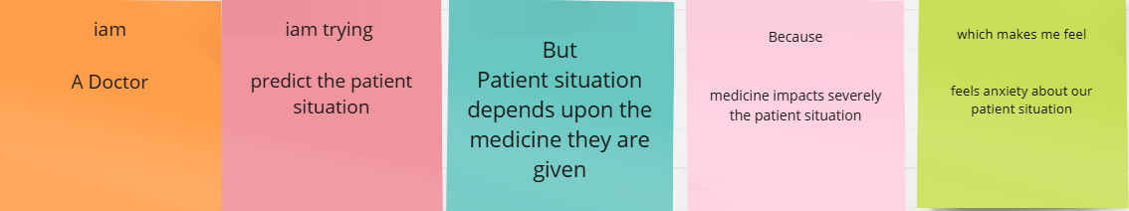

|  |  |  |  |  |  |
| --- | --- | --- | --- | --- | --- |
| **Problem**  **Statement (PS)** | **I am** | **I’m trying to** | **But** | **Because** | **Which makes me feel** |
| PS-1 | Doctor | Predict the patient condition | Patient situation depends upon the medicine they are given | Medicine impacts severely the patient situation | Feels anxiety about our patient situation |